Walk 21 Garway Hill
Last walked in October 2017

Description. A 6.4 km (4 mile) strenuous climb up and down hilly country. The 4 mile feels more like 5.
Start. Explorer Map 189 Grid 445269.
Directions from Tesco’s roundabout. (Turn milometer to zero). Follow the A465 to Abergavenny for a 7.1 miles and TL onto a minor road signed Garway Hill. At 8.1 miles TR at the T-Junction. At 9.2 miles TL at the next T-junction. At 10.3 miles at the hamlet of Bagwyllydiart, ignore the turning to the L and continue for 40 meters to TR signed Garway Hill. Continue along main road to park on the grass verge just before the red telephone box, total distance of 11.7 miles.

1. Telephone Box. Continue along the road and TL towards St Weonards. After 100m TL, at a Public Footpath sign, to go across a stile and down an enclosed track that’s on the R side of F1. Cross over a wooden fence that’s in the R hand corner and go into F2. Continue down this very rough fallow field; keep to the R of a stone building that’s in ruins and on into F3, (field fencing is not that prominent). Carry on down, as far as possible to the R side of this field to TR when you reach the concrete driveway, and then TL when you reach the road. Proceed along the road, passing Stoggle Oak that’s on your R, to TR at the first road junction. Go down to the bottom of this steep road to reach the drive at Lower Moors and TL to go thru the gate, then 10m on you TR and cross over a double stile into a field where you turn immediately L and continue up the L edge of F4.

2. Lower Moors. Cross a stile in the top L hand corner and along an enclosed track for 15m, then cross another stile into the next field F5. Keep to the L edge as you cross another stile in the top L hand corner and go into F6. Cross a stile at the end of F6 and continue up a track just inside a wooded area, to cross another stile onto a road and TL. Walk along this road to take the first road on your L, (at Bagwyllydiart), sign posted to Garway Hill. Continue up this road for almost a kilometre. You pass a chapel on your L by a fork in the road, as you continue onto Garway/Monmouth, and not far past ‘Ashfield’ which is on your L, you TR and go up an enclosed dirt track.
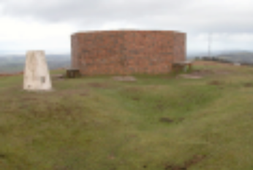
WW2 Radio tracking station

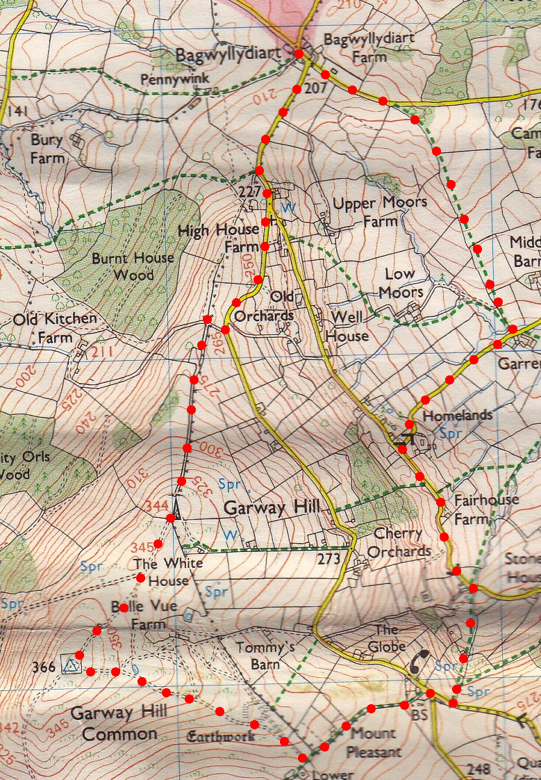
3. Dirt Track. 80m up this track you TL and continue up hill along an enclosed track. The track gets narrower and more enclosed as you proceed up hill, (ignore the metal gate on your R). At the end of the enclosed track you go thru a metal gate out onto the open hillside, a radio mast is just off to your L. Continue in the same direction, going up hill to reach the brick enclosure by the trig point at the top of Garway Hill. Garway Hill is a prominent local landmark rising to over 1200 feet. From the top of the Hill there is a view of seven counties in a 360-degree panorama. White mountain horses graze there most of the year and raise their foals amongst the bracken. Sheep roam freely. A pond near the summit provides a water supply for the animals which lasts all the year round, despite there being no visible source to keep it topped up. The pond is also home to a protected species of newt.

4. Garway Hill Trig Point. TL and go down a wide grassy path, along a ridge, keeping to the R of a pond to reach a fence. Follow the fence around to the R and reach a metal gate by Garway Hill notice board. TL and go thru the gate and down an enclosed stony track/drive to reach a road and TL to the car.

4
3
2
1

